컴퓨터공학부 | 20123434 | 황정담

[ 네트워크 최신기술 ]

[ MSNORT ]

제출일 : 2015.05.6

과제 요구사항

1. TCP 트래픽만 출력되도록 한다 🡪 mSnort.c의 int filter(mPacket_t *p) 함수 수정

void dissect (unsigned char *user, const struct pcap_pkthdr *h, const unsigned char *p)

{

…

// filter

if (filter (&pkt)) return;

// view

view (&pkt);

…

}

^dissect함수에서 filter()가 1을 return하면 dissect는 반환(종료)되고 0 을 return하면 해당 트래픽을 보여준다

* Filter()에서는 TCP트래픽일 때 0, 그렇지 않을 때 1을 return하게함.

수정 전)

int filter (mPacket_t *p)

{

#if 0

if (p->proto == IPPROTO_TCP &&

(ntohs (p->th.tcph->th_sport) == 22 ||

ntohs (p->th.tcph->th_dport) == 22)) return 1;

if (p->proto == IPPROTO_TCP &&

(ntohs (p->th.tcph->th_sport) == 3389 ||

ntohs (p->th.tcph->th_dport) == 3389)) return 1;

#endif

return 0;

}

수정 후)

int filter (mPacket_t *p)

{

if (p->proto == IPPROTO_TCP ||

(ntohs (p->th.tcph->th_sport) == 22 ||

ntohs (p->th.tcph->th_dport) == 22)) return 0;

if (p->proto == IPPROTO_TCP ||

(ntohs (p->th.tcph->th_sport) == 3389 ||

ntohs (p->th.tcph->th_dport) == 3389)) return 0;

return 1;

}

실행결과)

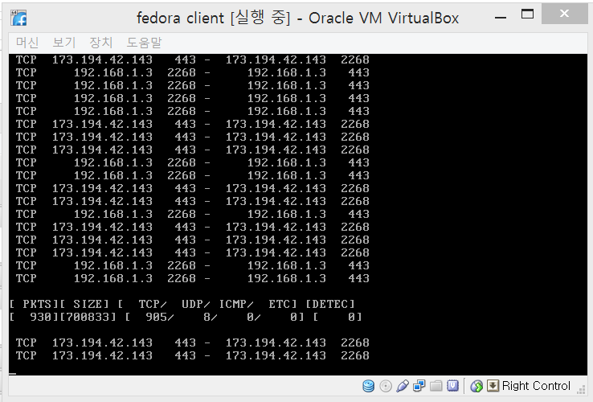

2. 두개의 패턴을 기준으로 탐지되어야 한다 (“GET” & “html”) 🡪 mSnort.c의 int search (mPacket_t *p) 함수 수정

void dissect (unsigned char *user, const struct pcap_pkthdr *h, const unsigned char *p)

{

…

// detection

if (search (&pkt)){

fprintf (stderr, "\t\t---- Detection !! -----\n");

}

return;

}

^dissect함수에서 serach()가 1을 return하면 패킷을 Detection하여 보여주고, 0을 return하면 함수가 반환(종료)된다.

* serach ()에서는 패턴을 감지했을 때 1을, 그 외에 0을 반환해야함

수정 전)

int search (mPacket_t *p)

{

// pattern, "GET "

char *pat = "GET ";

int len = strlen (pat);

if (p->payload_len < len) return 0;

if (strstr (p->payload, pat) == NULL) return 0;

return 1;

}

수정 후) pattern “html”추가.

int search (mPacket_t *p)

{

// pattern, "GET " & "html"

char *pat1 = "GET ";

int len1 = strlen (pat1);

char *pat2 = "html";

int len2 = strlen (pat2)

if ( (p->payload_len < len1) || (p->payload_len <len2)) return 0;

if ( (strstr (p->payload, pat1) == NULL) || (strstr (p->payload, pat2) == NULL) ) return 0;

return 1;

}

3. 탐지되었을 때, 패킷의 페이로드를 화면에 출력한다

수정 전)

void dissect (unsigned char *user, const struct pcap_pkthdr *h, const unsigned char *p)

{

…

// detection

if (search (&pkt)){

fprintf (stderr, "\t\t---- Detection !! -----\n");

}

return;

}

수정 후) detection출력후, dump_data실행

void dissect (unsigned char *user, const struct pcap_pkthdr *h, const unsigned char *p)

…

// detection

if (search (&pkt)){

fprintf (stderr, "\t\t---- Detection !! -----\n");

Dump_data(p, (unsigned int)h->caplen);

}

return;

}

실행결과)

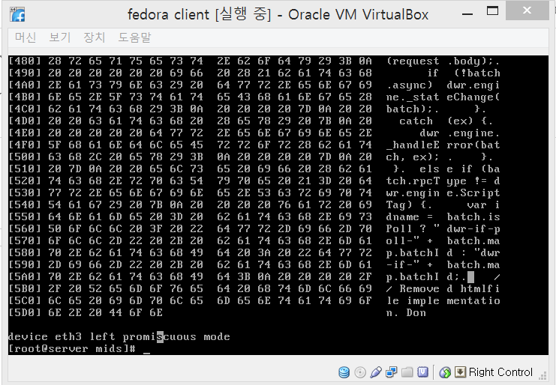

전체 소스코드)

다운로드 🡪 (클릭)

#include <unistd.h>

#include <string.h>

#include <ctype.h>

#include <signal.h>

#include <stdio.h>

#include <stdlib.h>

#include <stdarg.h>

#include <getopt.h>

#include <errno.h>

#include <time.h>

#include <unistd.h>

#include <signal.h>

//#include <sys/stat.h>

#include <fcntl.h>

#include <sys/socket.h>

#include <netinet/in.h>

#include <arpa/inet.h>

#include <netdb.h>

#include <sys/time.h>

#include <sys/wait.h>

#include <sys/types.h>

#include <dirent.h>

#include <linux/types.h>

#include <errno.h>

//#include <netinet/tcp.h>

#include <sys/file.h>

#ifdef LINUX

#include <linux/unistd.h>

#endif // LINUX

#ifdef __NR_gettid

#else // __NR_gettid

#define __NR_gettid 224

#endif // __NR_gettid

#ifndef MIN

#define MIN(a, b) ((a) < (b) ? (a) : (b))

#endif /* MIN */

#include "mSnort.h"

mStat_t stat;

void help ()

{

printf ("mSnort Ver 0.1.0\n"

"Usage: ./mSnort -i [Interface] -c [COUNT] -f [FILE]\n"

" -h Help\n"

" -i [INTERFACE] Interface ex) eth0\n"

" -f [FILE] File output ex) a.txt\n");

exit (0);

}

void print_asc (unsigned char *buf,int len)

{

int i;

for (i = 0; i < len; i++)

fprintf(stderr, "%c",isprint(buf[i])?buf[i]:'.');

}

void Dump_Data (unsigned char *buf, int len)

{

int i = 0;

if (len <= 0) return;

fprintf(stderr, "[%03X] ", i);

for (i = 0; i < len;) {

fprintf(stderr, "%02X ", (int)buf[i]);

i++;

if (i%8 == 0) fprintf(stderr, " ");

if (i%16 == 0) {

print_asc(&buf[i-16], 8); fprintf(stderr, " ");

print_asc(&buf[i-8], 8); fprintf(stderr, "\n");

if (i < len) fprintf(stderr, "[%03X] ",i);

}

}

if (i%16) {

int n;

n = 16 - (i%16);

fprintf(stderr, " ");

if (n > 8) fprintf(stderr, " ");

while (n--) fprintf(stderr, " ");

n = MIN(8,i%16);

print_asc(&buf[i-(i%16)],n); fprintf(stderr, " ");

n = (i%16) - n;

if (n > 0) print_asc(&buf[i-n],n);

fprintf(stderr, "\n");

}

fprintf(stderr, "\n");

}

int enable_core ()

{

int n;

struct rlimit rl;

if (getrlimit (RLIMIT_NOFILE, &rl) == -1){

return -1;

}

n = rl.rlim_cur = rl.rlim_max;

setrlimit (RLIMIT_NOFILE, &rl);

if (getrlimit (RLIMIT_CORE, &rl) == -1){

return -1;

}

rl.rlim_cur = rl.rlim_max;

setrlimit (RLIMIT_CORE, &rl);

return 0;

}

int decode (mPacket_t *p, char *pkt, unsigned short plen)

{

struct ip *iph = (struct ip *)(pkt + sizeof(struct ether_header));

struct tcphdr *th = NULL;

unsigned int ihlen = iph->ip_hl * 4;

unsigned int thlen = 0;

unsigned int offset;

unsigned int length;

if (iph->ip_v != 4) return -1;

if (iph->ip_off & htons(IP_MF|IP_OFFMASK)) return -1;

//Dump_Data (pkt, plen);

switch (iph->ip_p) {

case IPPROTO_TCP:

th = (struct tcphdr *)((const char *)iph + ihlen);

thlen = th->th_off * 4;

stat.tcp++;

break;

case IPPROTO_UDP:

thlen = sizeof(struct udphdr);

stat.udp++;

break;

case IPPROTO_ICMP:

stat.icmp++;

break;

default:

return -1;

}

p->mac.raw = pkt;

p->nh.iph = iph;

p->th.raw = (char*)iph + ihlen;

p->proto = iph->ip_p;

offset = sizeof(struct ether_header) + ihlen + thlen;

length = sizeof(struct ether_header) + ntohs(iph->ip_len) - offset;

p->payload = pkt + offset;

p->payload_len = length;

return 0;

}

void view (mPacket_t *p)

{

static unsigned int ti = 0, now;

now = time (NULL);

if (now > ti){

ti = now + 5;

fprintf (stderr, "\n[%5s][%5s] [%5s/%5s/%5s/%5s] [%5s]\n",

"PKTS", "SIZE", "TCP", "UDP", "ICMP", "ETC", "DETEC");

fprintf (stderr, "[%5llu][%5llu] [%5llu/%5llu/%5llu/%5llu] [%5llu]\n\n",

stat.cnt, stat.size,

stat.tcp, stat.udp, stat.icmp, stat.etc,

stat.detec);

}

// proto sip sport - dip sport

switch (p->proto){

case IPPROTO_TCP:

fprintf (stderr, "%4s %15s %5d - %15s %5d\n",

"TCP",

inet_ntoa (p->nh.iph->ip_src),

ntohs (p->th.tcph->th_sport),

inet_ntoa (p->nh.iph->ip_dst),

ntohs (p->th.tcph->th_dport));

break;

case IPPROTO_UDP:

fprintf (stderr, "%4s %15s %5d - %15s %5d\n",

"UDP",

inet_ntoa (p->nh.iph->ip_src),

ntohs (p->th.udph->uh_sport),

inet_ntoa (p->nh.iph->ip_dst),

ntohs (p->th.udph->uh_dport));

break;

case IPPROTO_ICMP:

fprintf (stderr, "%4s %15s %5s - %15s %5s\n",

"ICMP",

inet_ntoa (p->nh.iph->ip_src),

" ",

inet_ntoa (p->nh.iph->ip_dst),

" ");

break;

}

// payload ??

return;

}

int search (mPacket_t *p)

{

// pattern, "GET " & "html"

char *pat1 = "GET ";

int len1 = strlen (pat1);

char *pat2 = "html";

int len2 = strlen (pat2)

if ( (p->payload_len < len1) || (p->payload_len <len2)) return 0;

if ( (strstr (p->payload, pat1) == NULL) || (strstr (p->payload, pat2) == NULL) ) return 0;

return 1;

}

int filter (mPacket_t *p)

{

if (p->proto == IPPROTO_TCP ||

(ntohs (p->th.tcph->th_sport) == 22 ||

ntohs (p->th.tcph->th_dport) == 22)) return 0;

if (p->proto == IPPROTO_TCP ||

(ntohs (p->th.tcph->th_sport) == 3389 ||

ntohs (p->th.tcph->th_dport) == 3389)) return 0;

return 1;

}

void dissect (unsigned char *user, const struct pcap_pkthdr *h, const unsigned char *p)

{

mPacket_t pkt;

memset (&pkt, 0, sizeof (mPacket_t));

stat.cnt++;

stat.size+=h->caplen;

// decode

if (decode (&pkt, p, (unsigned int)h->caplen)) return;

// filter

if (filter (&pkt)) return;

// view

view (&pkt);

// detection

if (search (&pkt)){

fprintf (stderr, "\t\t---- Detection !! -----\n");

Dump_data(p, (unsigned int)h->caplen);

}

return;

}

void io_read (char *dev)

{

char *net;

char *mask;

int ret;

char errbuf[PCAP_ERRBUF_SIZE];

bpf_u_int32 netp; // ip

bpf_u_int32 maskp; // submet mask

struct in_addr addr;

struct pcap_pkthdr header; // Header that pcap gives us

char *file = stdout;

if (dev == NULL) return;

pcap_t *pcd;

pcd = pcap_open_live (dev, BUFSIZ, 1, 1000, errbuf);

if (pcd == NULL) {

fprintf (stderr, "Couldn't open device %s: %s\n", dev, errbuf);

return;

}

fprintf (file, "===================================\n");

fprintf (file, "Interface Info : %s\n", dev);

ret = pcap_lookupnet (dev, &netp, &maskp, errbuf);

if (ret == -1){

fprintf (file,"%s\n", errbuf);

return;

}

addr.s_addr = netp;

net = inet_ntoa (addr);

if (net == NULL){

perror ("inet_ntoa");

return;

}

fprintf (file,"NET : %s\n", net);

addr.s_addr = maskp;

mask = inet_ntoa (addr);

if (mask == NULL){

perror ("inet_ntoa");

exit(1);

}

fprintf (file,"MASK : %s\n", mask);

fprintf (file,"===================================\n");

pcap_loop (pcd, 0, dissect, NULL);

pcap_close (pcd);

return;

}

int init ()

{

memset (&stat, 0, sizeof (mStat_t));

return 0;

}

int main (int argc, char **argv)

{

char *dev = NULL;

int opt;

enable_core ();

while ((opt = getopt(argc, argv, "hi:d:")) != -1){

switch(opt){

case 'h':

help();

break;

case 'i':

dev = optarg;

break;

default:

break;

}

}

if (dev == NULL) {

fprintf(stderr, "Try `%s -h' for more information.\n", argv[0]);

exit(0);

}

init ();

io_read (dev);

return 0;

}